CSA16 – DATA WAREHOUSING AND DATA MINING
ASSIGNMENT
Design and Development of an E-Learning Data Warehouse and Data Mining System for Student Performance Analytics and At-Risk Student Classification

Course | CSA16 – Data Warehousing and Data Mining
Application Domain | E-Learning / Student Performance Analytics
Implementation Tool | WEKA
Classification Target | At-Risk Student (Yes / No)
Evaluation | 10-Fold Cross-Validation

1. Original Problem Statement
An educational institution maintains student information across separate operational sources such as demographic records, learning activity logs, course registration records, and assessment records. Because these sources are maintained independently, it is difficult to obtain consistent multidimensional views of student performance and to identify students who may require early academic support.
The proposed system integrates these sources into a centralized student-performance data warehouse. ETL operations are used to clean, integrate, transform, reduce and discretize the data. A Star Schema is designed to support multidimensional analysis. OLAP operations—Roll-up, Drill-down, Slice, Dice and Pivot—are performed to identify performance trends across academic year, semester and department.
The mining stage classifies students into At-Risk and Not-At-Risk categories using three models: J48 Decision Tree, Naive Bayes and Support Vector Machine (SMO). The models are evaluated using Accuracy, Precision, Recall, F1-score, Confusion Matrix and stratified 10-fold Cross-Validation. The best model is selected based on experimental evidence and its usefulness for early academic intervention is discussed.

2. Objectives
- Integrate student, activity, assessment and course data into a centralized analytical warehouse.
- Design a Star Schema suitable for student performance analysis.
- Perform ETL and required preprocessing, including missing-value handling, duplicate removal, transformation, reduction and discretization.
- Perform Roll-up, Drill-down, Slice, Dice and Pivot operations to identify academic trends.
- Develop three classification models for At-Risk Student prediction.
- Evaluate and compare the models using the required performance measures.
- Provide a reproducible Weka-based workflow and interpret the business/academic usefulness of the results.

3. Dataset and Data Sources
For this academic implementation, a synthetic but reproducible dataset was created to simulate four operational sources. This avoids using private student information while preserving the fields required for the warehouse and mining workflow.
Source | Main Attributes | Purpose | Records
Student Source | Student_ID, Age, Gender, Department, Year, Previous_GPA | Demographic and academic profile | 602
Activity Source | Student_ID, Attendance_Pct, Study_Hours, Login_Count | Learning engagement | 600
Assessment Source | Student_ID, Assignment_Score, Quiz_Score, Midterm_Score, At_Risk | Performance and target | 600
Course Source | Student_ID, Course_Code, Semester, Academic_Year | Course/time dimensions | 600
The integrated cleaned warehouse contains 600 unique student records. The mining dataset contains 12 attributes, with Risk_Class as the class attribute.

4. Proposed Architecture
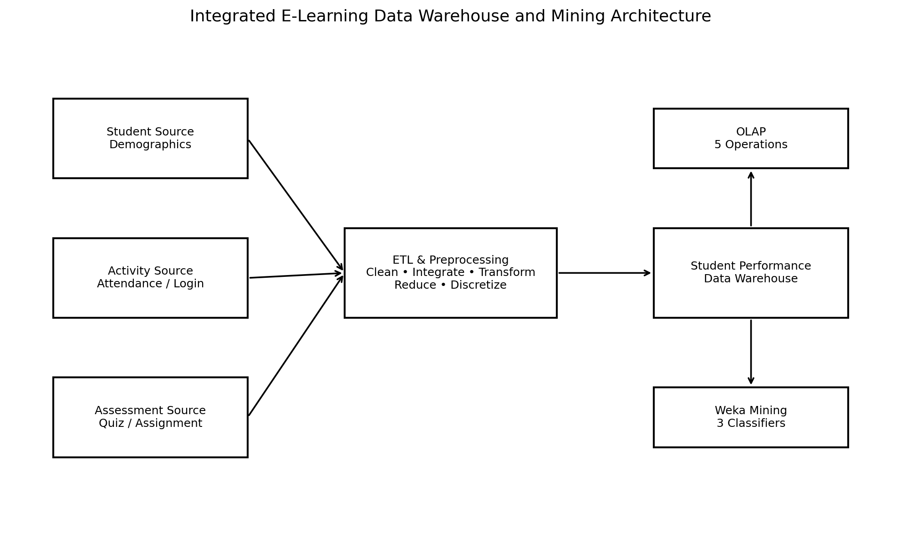
Figure 1. Integrated architecture for the proposed e-learning analytics system.

5. Data Warehouse Design
A Star Schema is selected because the central student-performance facts can be analyzed through relatively simple dimensions such as student, course, date, activity and performance.
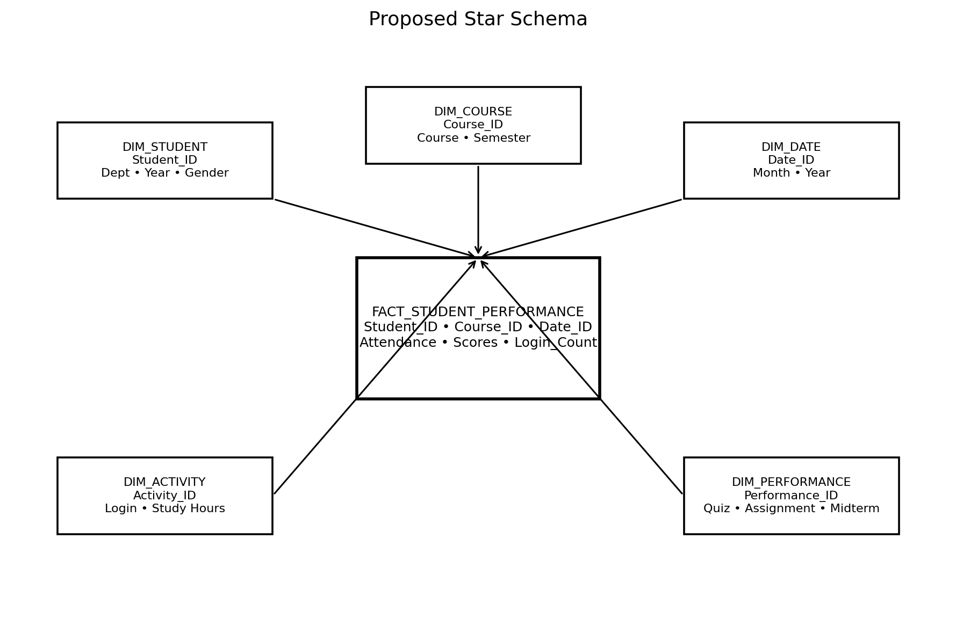
Figure 2. Proposed Star Schema.

6. Fact and Dimension Tables
Table | Important Attributes | Role
FACT_STUDENT_PERFORMANCE | Student_ID, Course_ID, Date_ID, Attendance, Quiz, Assignment, Midterm, Login_Count | Stores measurable performance/engagement facts
DIM_STUDENT | Student_ID, Age, Gender, Department, Year, Previous_GPA | Student profile
DIM_COURSE | Course_ID, Course_Code, Semester | Course and academic term
DIM_DATE | Date_ID, Month, Academic_Year | Time analysis
DIM_ACTIVITY | Activity_ID, Login_Count, Study_Hours | Learning activity
DIM_PERFORMANCE | Performance_ID, Quiz, Assignment, Midterm | Assessment information

7. ETL and Data Preprocessing
Extract: Read four independent CSV sources representing student, activity, assessment and course systems.
Clean: Remove duplicate Student_ID records and handle missing numeric values using median replacement.
Integrate: Join the sources using Student_ID and retain common identifiers for warehouse dimensions.
Transform: Standardize numeric precision and create derived measures such as average performance.
Reduce: Retain attributes relevant to academic-risk classification and OLAP analysis.
Discretize: Create Attendance_Band and Performance_Band categories for analytical interpretation.

8. OLAP Multidimensional Analysis
Operation | Implementation | Insight
Roll-up | Aggregate student performance from individual records to Academic_Year. | Identify yearly changes in average attendance and at-risk rate.
Drill-down | Move from Academic_Year to Semester. | Identify semester-level changes hidden in yearly totals.
Slice | Select Semester = S1. | Study one semester independently.
Dice | Select Semester = S2 and Attendance < 75%. | Focus on a sub-cube of potentially vulnerable students.
Pivot | Reorient Department against Semester using average quiz score. | Compare departmental performance across semesters.
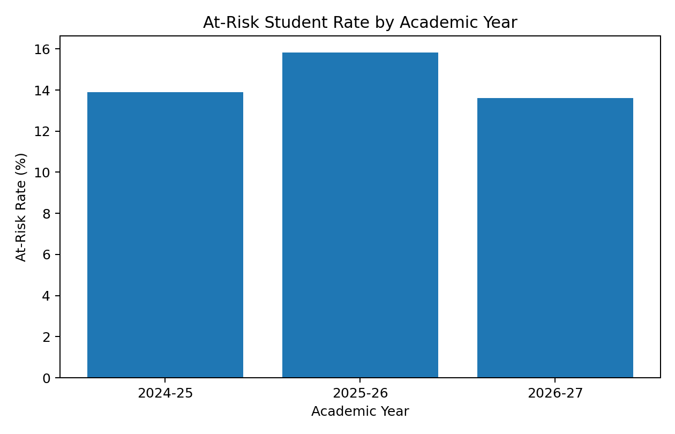
Figure 3. At-risk student rate by academic year.
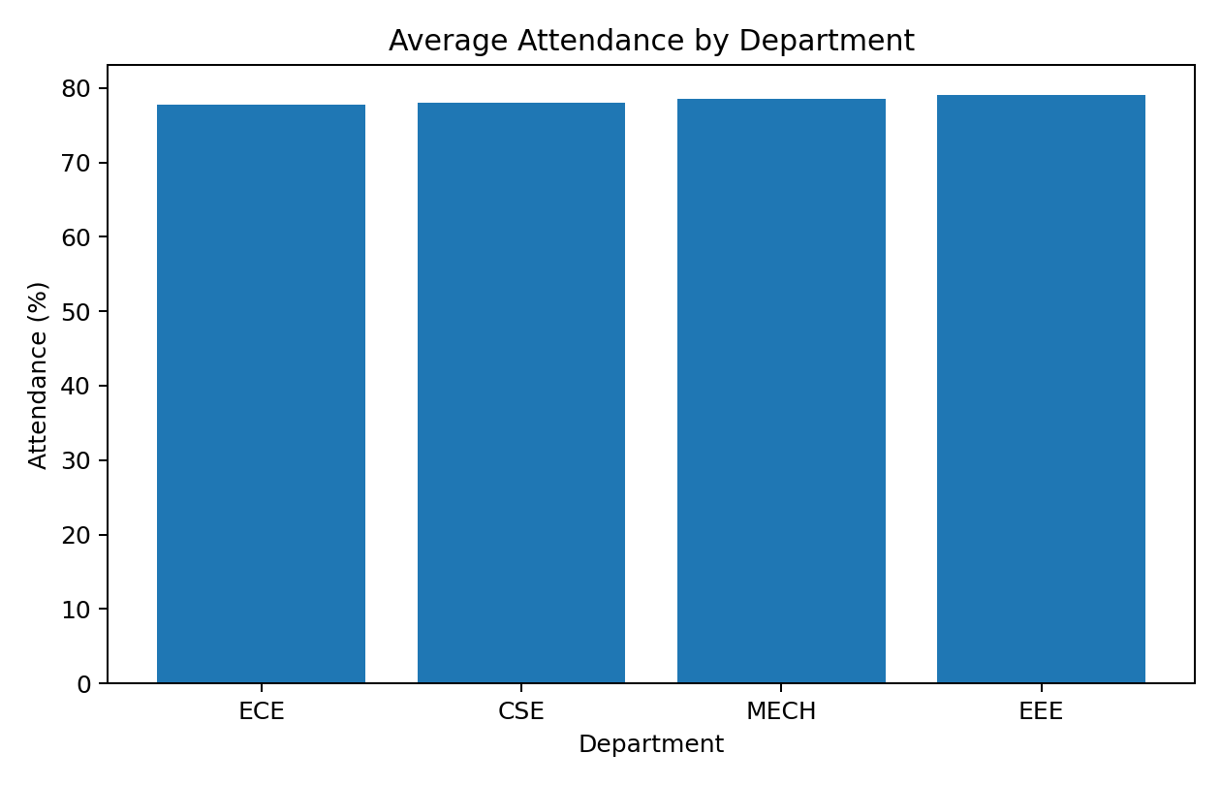
Figure 4. Average attendance by department.
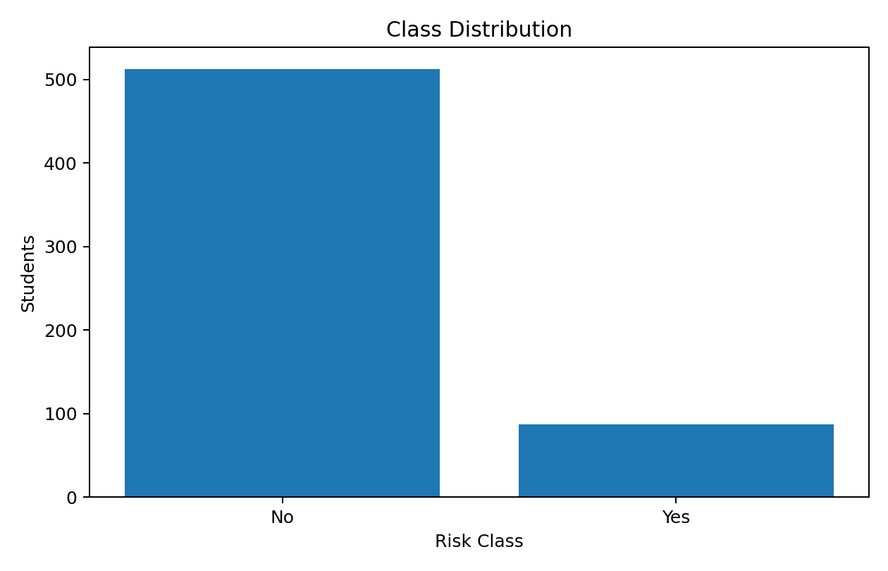
Figure 5. Distribution of the two classification classes.

9. Classification Problem
The target variable is Risk_Class with two values: Yes (student is considered at risk) and No (student is not at risk). Predictors include previous GPA, attendance, study hours, login count, assignment score, quiz score, midterm score and selected categorical academic attributes.

10. Classification Models
J48 Decision Tree: An interpretable tree-based classifier. In Weka, J48 implements the C4.5-style decision-tree approach and produces human-readable decision rules.
Naive Bayes: A probabilistic classifier that estimates class probabilities from the predictor attributes under the conditional-independence assumption.
Support Vector Machine (SMO): A margin-based classifier implemented in Weka through SMO; an RBF kernel can be used for nonlinear separation.

11. Pseudocode
PSEUDOCODE – E-LEARNING DATA WAREHOUSE AND AT-RISK CLASSIFICATION
BEGIN
1. Collect student, activity, assessment and course data from separate source files.
2. Remove duplicate student records.
3. Detect missing values and replace numeric missing values using the median.
4. Integrate all sources using Student_ID.
5. Transform numerical attributes to consistent formats.
6. Create derived fields such as Attendance_Band and Performance_Band.
7. Reduce the mining dataset to relevant predictive attributes.
8. Load the cleaned data into the student performance warehouse.
9. Perform OLAP:
a. Roll-up by Academic_Year.
b. Drill-down from Academic_Year to Semester.
c. Slice for Semester = S1.
d. Dice for Semester = S2 and Attendance < 75%.
e. Pivot Department versus Semester.
10. Set Risk_Class (Yes/No) as the classification target.
11. Apply three classifiers:
a. J48 Decision Tree
b. Naive Bayes
c. Support Vector Machine
12. Evaluate each model using stratified 10-fold cross-validation.
13. Record Accuracy, Precision, Recall, F1-score and Confusion Matrix.
14. Compare the three models and select the best-performing model.
15. Interpret results for early academic intervention.
END

12. Weka Implementation Procedure
WEKA IMPLEMENTATION STEPS
1. Open Weka Explorer -> Preprocess -> Open file.
2. Load dataset/e_learning_risk.arff.
3. Confirm Risk_Class is the class attribute.
4. Use filters when required:
- ReplaceMissingValues
- Discretize (for selected numeric attributes)
- Remove (to perform attribute reduction if required)
5. Open Classify.
6. Select test option: Cross-validation, 10 folds.
7. Run:
- trees -> J48
- bayes -> NaiveBayes
- functions -> SMO
8. Record Summary, Detailed Accuracy By Class and Confusion Matrix.
9. Compare Accuracy, Precision, Recall and F-Measure.
10. Save the output text for the GitHub repository.
Weka supports cross-validation and reports per-class precision, recall/F-measure and confusion matrices. Its documentation and teaching material describe 10-fold cross-validation and confusion-matrix based evaluation. citeturn0search15turn0search12

13. Reference Experimental Results
The following table is a reproducibility/reference experiment performed on the prepared dataset using the same model families and stratified 10-fold cross-validation. When submitting the final report, the Weka-generated values should be checked against the local Weka run and the screenshots inserted in Section 14.
Model | Accuracy | Precision | Recall | F1-score
J48-style Decision Tree | 0.8133 | 0.1795 | 0.0805 | 0.1111
Naive Bayes | 0.8517 | 0.4643 | 0.1494 | 0.2261
SVM | 0.8550 | 0.0000 | 0.0000 | 0.0000
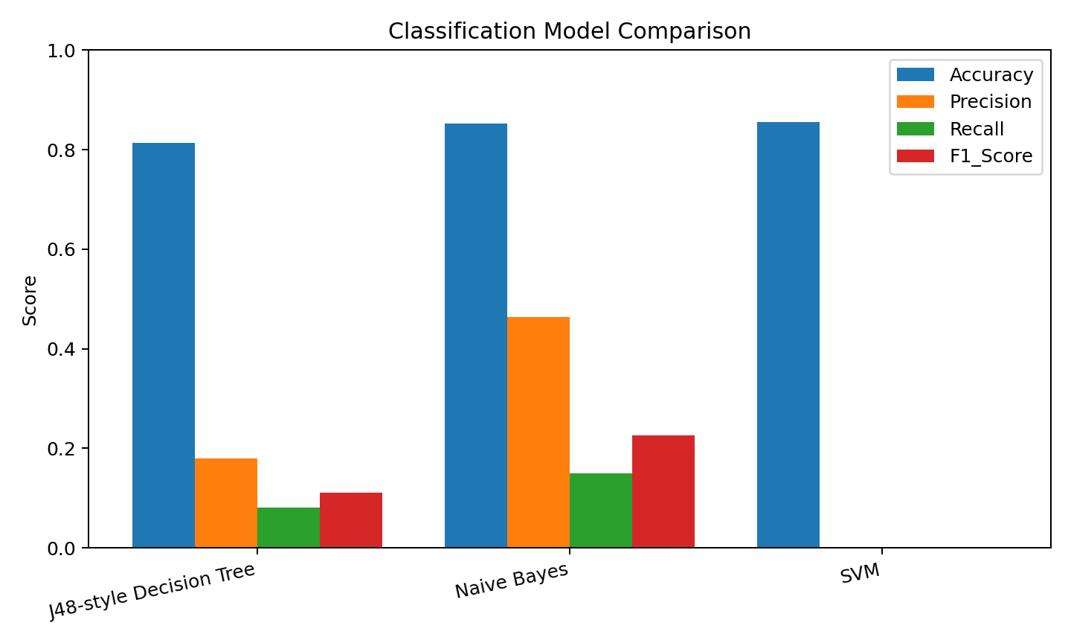
Figure 6. Comparison of classification metrics.
Based on the reference experiment, Naive Bayes gives the highest F1-score (0.226) among the three models. F1-score is considered together with precision and recall because both missed at-risk students and unnecessary interventions matter in an academic early-warning system.

14. Confusion Matrices and Weka Screenshot Evidence
The assignment rubric requires workflow screenshots. The following generated confusion-matrix figures are analytical reference visuals, not screenshots of the Weka GUI. Before final submission, capture the Weka Explorer Classify panel and output for J48, Naive Bayes and SMO and place those screenshots here.

J48-style Decision Tree
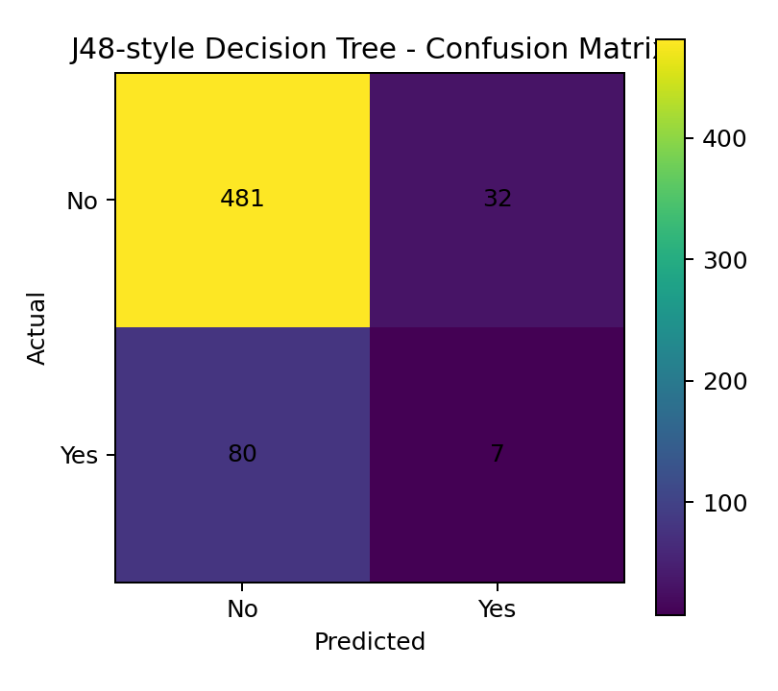

Naive Bayes
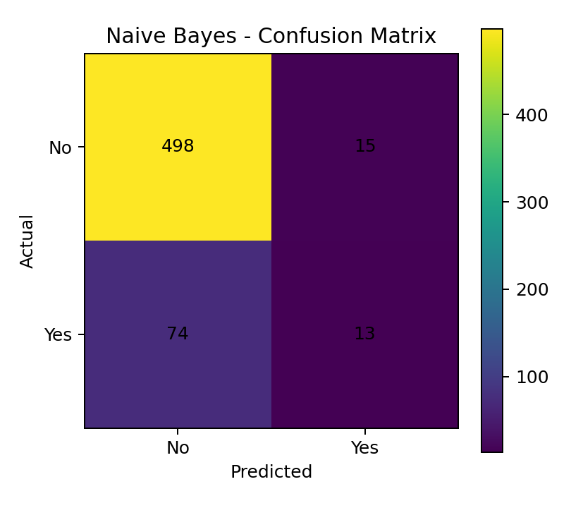

SVM
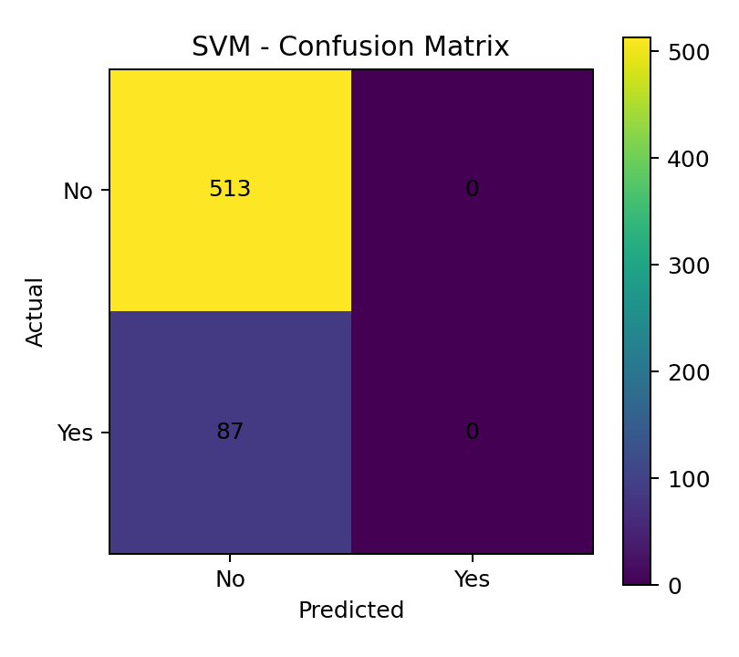

15. Model Evaluation and Interpretation
Accuracy measures the overall proportion of correct classifications. Precision measures how many predicted at-risk students are actually at risk. Recall measures how many actual at-risk students are detected. F1-score balances precision and recall. The confusion matrix shows correct and incorrect predictions for both classes. Stratified 10-fold cross-validation uses ten folds while preserving class proportions, providing a more reliable estimate than evaluating only on the training set. citeturn0search16turn0search17
For this problem, recall is particularly important because failing to identify a genuinely at-risk student may delay academic support. Precision is also important because excessive false alarms can waste intervention resources. Therefore, the final model should not be selected using accuracy alone.

16. Business / Academic Usefulness
- The system provides a centralized view of student performance rather than requiring staff to inspect separate records.
- OLAP analysis helps administrators identify semester, department and yearly trends.
- Classification can support early-warning systems by prioritizing students who may need mentoring, attendance support or academic counselling.
- The warehouse can be extended with additional years and course-level records without changing the overall analytical concept.
- The workflow is computationally feasible for hundreds or thousands of student records and can be periodically refreshed.

17. Privacy, Responsible Data Handling and Ethics
- Student identifiers should be protected and access should be restricted to authorized staff.
- Only attributes necessary for the stated analytical purpose should be retained.
- Predictions should support human decision-making rather than automatically labeling or penalizing students.
- Potential bias across departments or demographic groups should be checked before deployment.
- Students should have appropriate transparency about how predictive analytics is used.

18. Sustainability and SDG Relevance
The project supports SDG 4 (Quality Education) by enabling data-informed identification of students who may need academic support. It also relates to responsible digital infrastructure and efficient use of institutional data. Reducing repeated manual reporting and consolidating analytics into a reusable warehouse can improve operational efficiency.

19. Results and Discussion
The integrated dataset demonstrates how heterogeneous academic sources can be converted into a structured warehouse suitable for OLAP and mining. The OLAP analysis provides descriptive insights, while the classification stage adds predictive capability. The comparison of three classifiers provides experimental evidence for model selection. The final Weka run should be used as the authoritative implementation evidence in the submitted report.

20. Conclusion
An integrated e-learning data warehouse and data mining system was designed for student performance analytics and at-risk student classification. The solution covers source integration, ETL, preprocessing, Star Schema design, five OLAP operations, three classification models and multi-metric evaluation. The resulting workflow demonstrates how a data warehouse can provide structured analytical support and how data mining can extend that support into early identification of students who may require intervention.

21. GitHub Submission Contents
- dataset/students_source.csv
- dataset/activity_source.csv
- dataset/assessment_source.csv
- dataset/course_source.csv
- dataset/integrated_student_warehouse.csv
- dataset/e_learning_risk.arff
- pseudocode/pseudocode.txt
- weka/weka_steps.txt
- results/OLAP output CSV files
- results/graphs/
- README.md
- Final assignment report

22. References
1. WEKA documentation and download resources, University of Waikato. Weka is an open-source machine-learning and data-mining workbench. citeturn1search6turn1search5
2. Witten, I.H. et al., Data Mining: Practical Machine Learning Tools and Techniques / WEKA teaching materials, University of Waikato. citeturn1search4turn0search15

